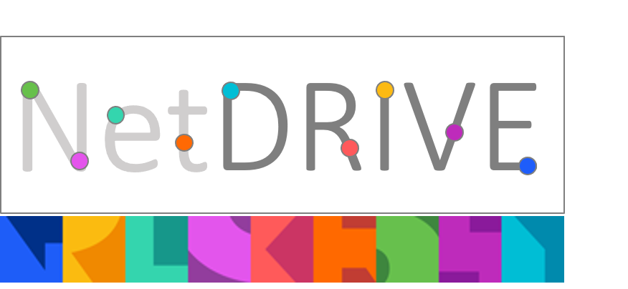

ONE-PAGE ABSTRACT TEMPLATE AND GUIDELINES –TITLE CENTERED AND ALL CAPS

First name Family name of Primary Author, Affiliation
First name Family name of next author, Affiliation
First name Family name of next author, Affiliation
First name Family name of next author, Affiliation

Email address of Presenting Author

Key Words: List up to five key words.

These guidelines have been prepared in the format that should be used for the poster abstract submission. Authors should replace the text of this template in order to prepare their abstracts. Fonts, sizes, and spacing should be used exactly as shown in this document. The page size is A4 (210 × 297 mm), with top, bottom, left, and right margins of approximately 20 mm. Body text should be written in Arial, 10 pt, single spacing. The abstract, written in English, should introduce the proposed work’s subject, summarise its contents, explain any unique or innovative aspects, and clearly indicate its relevance to the NetDRIVE Community Meeting themes and to the UK DRI Net Zero Roadmap for Digital Research Infrastructure. Authors should explicitly describe how their contribution informs, supports, or advances sustainable digital transformation and progress towards net-zero DRI. Do not subdivide the text into separate sections. References may be included at the bottom. The abstract may contain images, graphs, or tables to help draw attention to the subject matter, provided the content remains within the prescribed format. The abstract must not exceed 300 words.

Relevance to the UK DRI Net Zero Roadmap
All abstracts must explicitly reference and engage with the UK DRI Net Zero Roadmap, demonstrating how the work:
- Aligns with roadmap priorities, or
- Addresses challenges, opportunities, or gaps identified in the roadmap, or
- Provides case studies, tools, methods, or insights that support net-zero digital research infrastructure

Abstracts that do not clearly articulate this link may be considered ineligible.

Submission Process
- Submit your completed abstract by email to: netdrive@eng.ox.ac.uk
- The abstract shall be submitted as Word File (.doc or .docx).
- Email subject line: NetDRIVE2026_Abstract_Surname
- Please indicate in your submission whether you are an early-career researcher or professional.
- Please indicate your career stage in your submission by selecting one of the following categories:
  - C1: First Stage Researcher (up to the point of PhD), or software engineer (degree and 2–4 years’ work experience), or equivalent in another relevant profession
  - C2: PhD holder, or software engineer with 5 or more years’ work experience, or equivalent
  - C3: Independent researcher, software engineer with a management role, or equivalent
  - C4: Researcher leading a research area or field, or senior management
- Abstract submission deadline: 2 March 2026
- Notification of acceptance: 12 March 2026
- Confirmation of participation: 19 March 2026
Accepted posters will be on display during the whole meeting, and a prize will be awarded to the best poster!

We particularly encourage submissions from early-career researchers, and contributions that bridge technical, policy, and community perspectives.

